LP30483 – A work-based research project looking at how VR and AR can be demonstrated to be improving the teaching of history.

# Abstract

An action plan has been produced for a research project, to ensure its development doesn’t suffer from poor project management. The deliverables, objectives and research question have been written to help demonstrate that virtual reality and augmented reality (VR and AR) have a positive effect on history education. Constraints such as not enough time, scope creep and lack of accessibility to hardware have been noted, as have ethical and legal issues to do with participants’ personal data. A comprehensive list of resources have been identified to show the requirements to produce 3D models, an interactive VR environment and reliable, externally valid data. This, coupled with risks properly identified, and the sponsor’s support for the project contained in a separate document, suggest that the research project will successfully demonstrate VR and AR’s effectiveness in improving history education.

Contents

Abstract 1

Introduction – overview of the project 2

Project Objectives 3

1 3

2 3

3 3

4 3

5 3

6 4

7 4

Project Deliverables 4

1 4

2 4

3 4

4 4

5 4

6 4

7 4

My research question stated – a justification to show how the research results from the literature review will be used in the project 4

Paper 1 – (Neamtu, et al., 2012) 4

Paper 2 – (Eggarxou, 2007) 4

Paper 3 – (Kuo & Lévis, 2002) 5

Paper 4 – (Black, 2017) 5

Paper 5 – (Yildrim, et al., 2018) 5

Paper 6 – (Pletinckx, et al., 2000) 5

How these findings will be utilised 5

The project constraints, including those relating to hardware & Operating Systems and those applied by the sponsor 5

Time 6

Cost 6

Scope 6

From the sponsor 6

A statement of legal, ethical and professional issues – Is Data Protection registration necessary? Does the sponsor know my expertise? Is the work confidential? 6

Ethical 6

Legal 6

Professional 7

Software 7

Hardware 8

Personnel 8

Resources required for the project 8

Software 8

Hardware 9

Personnel 9

Risk assessment 9

Letter from sponsor – confirming participation in project, and the time/resources they’ll be providing 11

Project plan 11

Schedule 13

Gantt Chart 15

SWOT Analysis 17

References 17

Appendices 19

A – Additional information for Paper 1 (Neamtu, et al., 2012) 19

B – Additional information for Paper 2 (Eggarxou, 2007) 20

C – Additional information for Paper 3 (Kuo & Lévis, 2002) 22

D – Additional information for Paper 4 (Black, 2017) 23

E – Additional information for Paper 5 (Yildrim, et al., 2018) 24

F – Additional information for Paper 6 (Pletinckx, et al., 2000) 25

# Introduction – overview of the project

This action plan was produced for a research project that aims to address the question “Can VR (Virtual Reality) and AR (Augmented Reality) be demonstrated to be improving the teaching of history?” Recent developments in VR and AR have demonstrated their ability to improve history education (Neamtu, et al., 2012), (Eggarxou, 2007), (Yildrim, et al., 2018). The topic was chosen out of personal interest in history and how new technology can be developed in the future to improve the experience.

Keeping in mind how history education is innovated through other multimedia (Skillshare, 2019), (Jaffar, 2012), (Burke & Snyder, 2008) as well as through VR (Kuo & Lévis, 2002), (Black, 2017), a group will be given a VR application teaching European history between 1871-1919. A brief pilot study will have also been conducted where participants experience a simple simulation of a building in VR and are asked how much they can remember about it, before being given a textbook about another building and asked similar questions. As stated, the main project will be teaching 1871-1919 European history, through a virtual tour of the Palace of Versailles, where in 1871 and 1919 the German Empire was proclaimed and dissolved respectively (Palace of Versailles, 2020). It will be taught with young adults in mind. Meanwhile, a control group will be given a more orthodox teaching method through the use of textbooks about the same period, with the same topics covered, which will act as a useful baseline to compare teaching history through VR and non-VR (Pithon, 2013). After which, these groups will firstly be given the same questionnaire regarding historical information that they learned using the application. A new second test will be given to the main group, asking for their opinions on how the VR headset affected the learning experience, and if they considered it superior to textbook education. The control group meanwhile will be asked in their own second test their opinion on how the textbook material was taught to them. These results will then be compared to measure the difference in effectiveness.

The questions asked will be both open-ended and multiple choice, producing both quantitative and qualitative data. This will provide both insight that’s easily displayable along with in-depth answers from participants when appropriate. Content analysis will be conducted upon qualitative data to turn it into quantitative. This will be useful for representing the data fully in graphs. The plan is to conduct this questionnaire electronically online.

# Project Objectives & deliverables

The objectives in this project represent the direct outcomes, or what is being achieved. Deliverables, meanwhile, are the object itself. These are detailed below.

# Project Objectives

## 1

To build a pilot study to test logistics and gather information, thus being able to better determine how the main study can be approached, as well as backing up previous research in this field.

## 2

To educate users on history with VR through a simulation of the Palace of Versailles.

## 3

To design a series of questionnaires that will determine the effectiveness of VR education in history and how it compares to textbook education in history.

## 4

To gather appropriate qualitative and quantitative data through the use of the aforementioned questionnaires.

## 5

To analyse the gathered data with content analysis and represent it in comprehensible graphs.

## 6

To test the simulation with participants that will interact with the environment and learn history through VR.

## 7

To determine conclusions based on the gathered data from both the graphs and qualitative data obtained from the questionnaire.

# Project Deliverables

## 1

The results of the pilot study that will help bring additional insight into how to best conduct the research.

## 2

A 3D virtual model of the Palace of Versailles.

## 3

A series of questionnaires that will determine VR effectiveness in history education and its effectiveness relative to history textbook education.

## 4

Results from the questionnaire; qualitative and quantitative data gathered from participants.

## 5

A graph of the research results.

## 6

A virtual tour of the Palace of Versailles that teaches users about history through the use of VR.

## 7

Conclusions drawn based on the qualitative and quantitative results from the questionnaire.

# My research question stated – a justification to show how the research results from the literature review will be used in the project

The research question is “Can VR and AR be demonstrated to be improving the teaching of history?” The research will aim to be proving that VR improves the way history can be taught, with the research from the literature review supporting the research project.

## Paper 1 – (Neamtu, et al., 2012)

This study regarded remodelling old Dacian (ancient Romanian) ruins in VR for higher education students studying archaeological history who were unable to visit the site. Their methods proved successful, supporting the project’s hypothesis that VR and AR can be demonstrated to be improving the teaching of history. Additional information is within Appendix A.

## Paper 2 – (Eggarxou, 2007)

The Erechtheum was remodelled in VR in this research, with findings showing VR helped visualise the building’s nature to students and that average scores on tests were higher from those who learned via VR, relative to those who’d learned via textbooks. Additional information is within Appendix B.

## Paper 3 – (Kuo & Lévis, 2002)

This study examined VR’s affect in teaching about historical architecture in ancient Rome. Results showed the performance of teachers as well as students was improved through the use of VR. Additional information is within Appendix C.

## Paper 4 – (Black, 2017)

This study examined primarily pre-university history education. It illustrated VR can provide an improved teaching experience, with observations noting its immersive effects were unachievable in the real world, thus supporting the hypothesis. Additional information is within Appendix D.

## Paper 5 – (Yildrim, et al., 2018)

This study examined VR’s uses in undergraduate history education. Results were generally positive, supporting the idea that “VR and AR can be demonstrated to be improving the teaching of history”. Additional information is within Appendix E.

## Paper 6 – (Pletinckx, et al., 2000)

This study examined a museum in a medieval Belgian town that utilises VR and AR. Findings suggested that historical research were positively influenced by VR. Additional information is within Appendix F.

## How these findings will be utilised

Paper 1 illustrates that the Palace of Versailles can be modelled accurately enough to illustrate to the user its scale, dimensions and most notable parts of the building. The results indicate it’s important to model as faithfully to the building’s design as possible to improve the educational quality the VR delivers.

Paper 2 illustrates that VR education can be superior to textbook education by accurately recreating environments. This indicates the importance of conveying information as fully as a textbook would through the VR’s environment, as well as text pop-ups and narration.

Paper 3 illustrates that teachers as well as students both show increases in performance through VR history education. This shows that the VR should be extensively tested both by participants and myself to better improve the quality of the application, obtaining the insight into how to best teach the subject that a textbook might not otherwise be able to.

Paper 4 and 5 provide useful insight on the younger bracket of the 16-25 age demographic. They also demonstrate the potential for recreating events of history virtually, demonstrating valuable ways to pursue educating users, such as showing them through their own eyes what’s going on in an environment. This can be utilised in video sections, letting the viewer behold footage from the period with minimal commentary, improving education by not interfering with user attention.

Paper 6, and ultimately all of the literature review studies’ findings, can be used to show VR catches the interest of its users, improving the learning experience by making them pay more attention. It’s therefore important to examine pilot study feedback and make sure that the content produced in the main project is engaging and not boring. Paper 6 also demonstrates that AR can be combined with VR to improve education.

# The project constraints, including those relating to hardware & Operating Systems and those applied by the sponsor

A constraint is defined by the project management triangle as being in one of three categories: time, cost and scope (Tutorialspoint, 2020). A model of the triangle can be seen below.

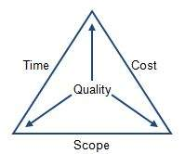

**Figure 1** (Tutorialspoint, 2020)

This model will be used to analyse and sort the project constraints, and leave them out if they don’t fit exactly in.

## Time

Once data is obtained, a constraint is the time it will take to analyse the data. This will include graphing quantitative results, recording qualitative results in tables and performing content analysis on the qualitative data. Thankfully, past experiences with content analysis and graphing results should ensure this constraint will not be problematic. Regardless, time has been allocated to have the data analysis complete before the deadline.

## Cost

Due to the project being undertaken in an educational, non-paid environment, costs are a tertiary issue. This constraint only appears in regard to the quality of available hardware. As more expensive hardware is unavailable to be purchased for research, the software’s negative effect on performance must be reduced as much as possible to ensure it runs functionally on college hardware.

## Scope

The biggest constraint in general is the lack of experience and skill in working on a research project. If these issues are not overcome, scope creep can occur and cause issues in the project’s development. However, following the project plan closely and allocating extra time in the event parts of the project take too long will help ensure the research project is completed regardless.

More specifically, the final state of the deliverables will be influenced by how well 3DSMax, Adobe Premiere, Unity, PowerPoint/Paint and WebStorm are utilised. The lack of familiarity with 3DSMax relative to programs like Unity is a considerable constraint, though extra time has been allocated to 3D model development in the project plan to account for a lack of familiarity.

## From the sponsor

The final category of constraints includes those indirectly given by the sponsor. These constraints to the project are tertiary, and only cause minute changes to the existing project plan. The tasks and activities agreed upon by all parties are detailed in the attached sponsor agreement.

# A statement of legal, ethical and professional issues – Is Data Protection registration necessary? Does the sponsor know my expertise? Is the work confidential?

## Ethical

In regard to ethical issues, ensuring that the data from participants is kept confidential, as well as ensuring they are aware that they may withdraw their data at any time, is essential. It’s also important to ensure anonymity remains uncompromised. If the need to refer to a particular individual’s data arises (e.g if there is an outlier in the results worthy of referring to) they may be referred to, albeit under a pseudonym such as “Participant A”. Finally, deceitful practices will be avoided during the research, ensuring that the informed consent of participants is acquired before gathering data from them. When qualitative data is being gathered, the question should be open-ended and written in a fashion that doesn’t force the participant to give away more information than they are comfortable with doing. By using Martyn Descombe’s principles for good research, the principle “researchers need to protect the interests of participants” (Denscombe, 2002) should be followed very closely. By doing this, many ethical issues are avoided simply by not making the participants upset.

## Legal

Similarly, significant legal issues include taking into regard the Data Protection Act. It’s important that the “data protection principles” are followed as per the guidelines of the UK government (GOV.UK, 2020). As listed by the government’s website, these guidelines are to ensure information is:

1. used fairly, lawfully and transparently
2. used for specified, explicit purposes
3. used in a way that is adequate, relevant and limited to only what is necessary
4. accurate and, where necessary, kept up to date
5. kept for no longer than is necessary
6. handled in a way that ensures appropriate security, including protection against unlawful or unauthorised processing, access, loss, destruction or damage

(GOV.UK, 2020)

Points 1 and 2 can be followed by being honest with the participants, and as the research requires no need for deception, these guidelines should not cause problems during the project’s course. Point 3 can be used to not only obey the law but to also ensure resource allocation (i.e time) is used as optimally as possible. Point 4 is addressed by displaying the answers of the participants honestly and, when appropriate, in their original form. The exception to this will be in the case of content analysis, when turning quantitative data into qualitative data. After data has been collected, key words will be looked for within the user’s answer and given a numerical rating. For example, if the user describes additional aspects that they enjoyed as “excellent” or “good”, these can be assigned values of 5 or 4, where 5 is the highest rating and 1 is the lowest. Points 5 and 6 can be followed by ensuring data is not published in a way not stated in the project plan and to the participants, as well as ensuring it is published securely and anonymously.

## Professional

Finally, professional issues to consider are primarily related to the project sponsor. Behaving in a courteous manner and being as co-operative as possible with the sponsor will help avoid professional issues. As a student, little professional experience has been had, so to avoid professional issues, abiding by existing professional standards provided by UK-based research organisations (AQR, 2020) should be a priority.

### Software

An issue with 3DSMax is the lack of experience I have with using it. While this can be solved to a degree through the use of assets, additional time will also be allocated to learn and master 3DSMax. Assets will be selected only if the deadline approaches and the 3D models remain unfinished. This will be covered further in the risk assessment section.

Past experience, however, means that Unity will not have such an issue. An issue to consider however is that performance could be hindered if the VR environment is poorly optimised. Reducing/reusing textures, utilising “frustrum culling” (Lighthouse3D, 2020) and audio compression/decompression can be used to improve Unity performance.

Adobe Premiere is intuitive and dynamic, though an issue is that the software will only be able to be used on the college campus. This limits the amount of time videos can be put together, meaning video production and completion should be concluded as soon as possible to avoid these issues.

Due to the familiarity with Microsoft PowerPoint and Paint and their availability, issues with these programs should be non-existent.

WebStorm, being a versatile, dynamic program, has few issues on its own. However, a lack of experience with WebStorm will be something taken into account when developing the Gantt chart.

In regard to the VR environment, the time taken to write the software before beginning implementation is both a issue and risk. Testing both on the developer and participant end will be a considerable issue, particularly in the former’s case, as issues will be encountered in development and fixed. Fixing issues within the VR application will be the result of enough testing. Testing should be allocated as much project time necessary in order to ensure the VR environment is fully functional.

As the operating system (OS) chosen will be Windows 10, the version of which will be universal across all devices used to develop the project, no issues related to the OS are foreseeable.

### Hardware

A necessity of the software is ensuring that it’s not an intensive program to run, as the hardware participants will use is not of the most up-to-date quality. Therefore, keeping the limiting hardware specifications in mind, and optimising the performance of the VR (e.g reducing object quantity to ensure a constant frame rate) is critical.

Another issue is the accessibility to a VR headset. As the equipment will be provided by the college, the headset will remain on campus. This means that the time available to access the VR hardware can potentially be limited. It’s important, therefore, to appropriately follow the project plan, and stick to the allocated time for each aspect of the project. Planning ahead for potential scope creep by ensuring the project is finished a few weeks before the deadline is also a solution to this issue.

### Personnel

An issue will be finding the participants of both a pilot study, control group and main group for research. For the pilot study, a volunteer sample can be utilised, as it will be small-scale. For both the control group and main group of the research project, co-ordinating with the college to find students willing to take part in the research will be the first plan. If this fails, participants can also be found through extra-curricular activities I take part in. The control group will be a simpler sample to obtain as they do not require to use the VR headset and environment, and can simply read the appropriate passage from a textbook and answer the necessary questions online.

# Resources required for the project

## Software

3DSMax will be employed when creating the virtual environment. Ideally, all aspects of the Palace of Versailles will be created without the use of assets and put together in a cohesive manner, which 3DSMax provides services for (Autodesk, 2020). However, if scope creep becomes an issue with the project, assets will be considered to be employed within the virtual environment. More information is included on this within the risk assessment section.

Unity will be used to run the virtual environment. Through the use of aspects such as an FPS Controller, and Unity’s lighting effects, a realistic simulation of a tour throughout the Palace can be achieved with Unity’s “rich visual fidelity” and “artist-friendly tools” (Unity, 2020).

Adobe Premiere will also be a necessary piece of software, as this will allow videos to be put together and played to the user. Developer narration can be inserted alongside relevant images and video, and basic diagrams and maps drawn out in programs such as PowerPoint or Paint can be inserted as well. Premiere also provides support for VR, increasing its viability for use in the project (Adobe, 2020).

Microsoft PowerPoint, Paint and similar tools will be utilised to build basic diagrams to visually represent appropriate aspects, when available videos and images are not available to be inserted. PowerPoint will be the primary software for this role, as it features built-in support for building charts (Microsoft, 2020).

For the website, the IDE WebStorm will be employed, due to the high versatility that JetBrains software features. It also features support for JavaScript, a language commonly utilised to build questionnaires (JetBrains, 2020). If time constraints render completing the website impractical, a Google Forms survey will be employed instead to collect the data. This will be expanded upon further in the risk assessment section.

## Hardware

For the VR experience, it’s important that a VR headset is included. The headset to be utilised in this scenario is the Oculus Rift.

The next requirement will be a computer capable of running a game non-intensive on computer hardware. To answer the survey, a website, built especially for this research or otherwise, will also need to be able to be run from the aforementioned computer hardware.

## Personnel

The most important personnel will be the participants data is gathered from. These will be young adults with the age range being 16-25 years old. Participant feedback is a critical part of the research project and must be gathered as best as possible. There will need to be participants found for the pilot study, main group and control group.

# Risk assessment

Severity and probability will be rated from 1-5, with 1 meaning a very low severity/probability and 5 meaning a very high severity/probability.

|  |  |  |  |
| --- | --- | --- | --- |
| **Risk** | **Severity** | **Probability** | **Solution** |
| Law change | 5 | 1 | Due to the low likelihood and high severity it is best to act in accordance with the current law as closely as possible, so that in the event changes occur the new scope arranged would be as similar to the previous one as possible. |
| Sponsor requesting too large a change | 4 | 2 | Due to the project being planned in anticipation of this, there will be time to accommodate a few additional changes. The sponsor will be informed if said changes are unfeasible. |
| Illness | 4 | 2 | Ensure that tasks are completed with time to spare, allowing time to be taken off if recovery is necessary. |
| No sponsor input for the project | 3 | 3 | Ask the sponsor leading questions in emails, follow-up and contact them in the event further feedback is required. |
| Legal issue from third party | 3 | 1 | If ensuring to give all events an unbiased view fails, negotiate with the third party until they are satisfied with the changes made. |
| Not getting the application working | 5 | 2 | Consider starting the section again. Look closely for minute errors. If applicable, resort to using a backup method (e.g using Google Forms to collect data rather than my own website, as mentioned). If all else fails, request an extension. |
| Poor planning | 4 | 1 | Think as far ahead right now as possible, anticipating any potential issue as small as it might be. Identify all tasks and break them down into smaller sub-tasks, to properly understand what’s required. |
| Poor time allocation | 4 | 1 | Look closely at the project plan now and properly judge how long tasks will realistically take. Plan in advance in case delays occur. |
| Inability to collect data | 5 | 3 | Employ one of the aforementioned alternative means of finding participants. |
| Inability to collect appropriate data | 5 | 3 | Make clear in the brief to participants exactly what is being asked for. Ensure that questions are not misleading and do not use complex language. |
| Insufficient data for analysis | 5 | 2 | Search for other potential participants to partake from extra-curricular groups. If this is unfeasible, consider using a opportunity sample. If this is also impossible, reference similar studies, and acknowledge mistake. |
| Insufficient time | 4 | 2 | Follow the project plan as closely as possible to avoid time issues. Plan ahead in the event delays are encountered. |
| 3D models unfinished | 2 | 2 | In the event this occurs, assets online will be looked for instead and used in place. Effort will be put to ensure the assets chosen are well-made, artistically cohesive and not immersion-breaking. |

Overall, sticking to the project plan closely and not straying far from its guidelines will reduce the probability of risks considerably. By finishing these tasks on time, spare time becomes available to be spent addressing future unexpected obstacles and adjusting the project should the sponsor make this request.

# Letter from sponsor – confirming participation in project, and the time/resources they’ll be providing

The letter from the sponsor contains a confirmation of their participation in the project. The objectives, tasks and activities have been identified, and signed off by the sponsor and myself. The agreement can be found attached in the file this report was submitted on.

During development, Norman and Schneiderman’s principles for good human-computer interaction (HCI) will be considered to ensure that the sponsor is pleased with progress. User Centred Design (UCD) will also be considered, ensuring the sponsor is as satisfied with the project as possible. These can be viewed in more detail in Appendices G and H.

# Project plan

The Gantt Chart and Schedule as they exist are a rough guideline. As the project progresses, these fields may need to be adjusted as a result of unforeseen issues and scope creep.

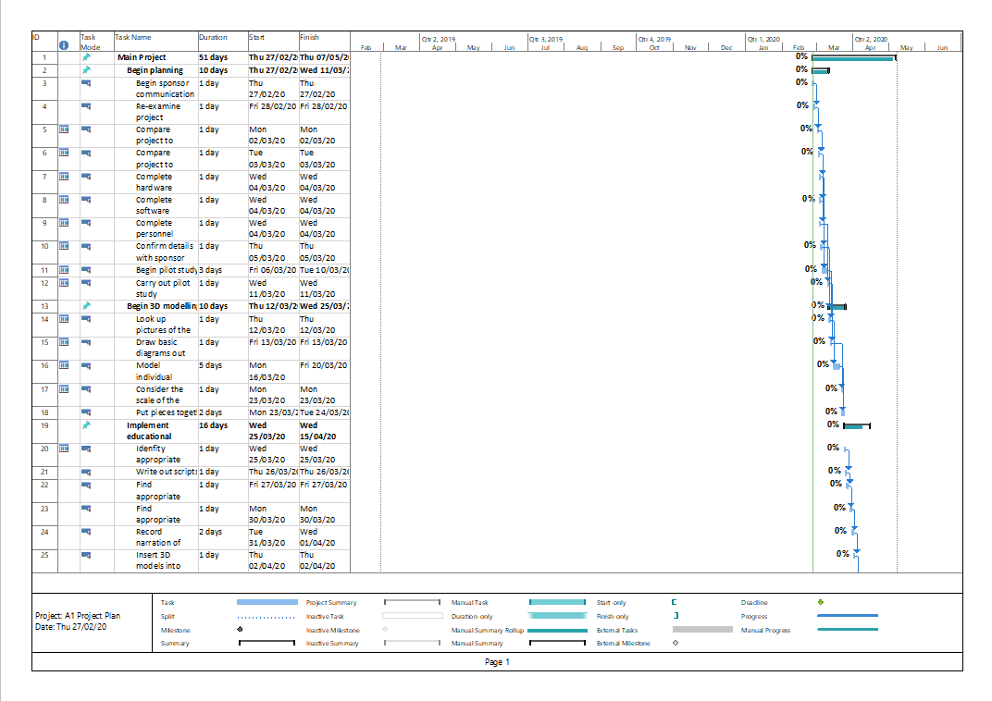

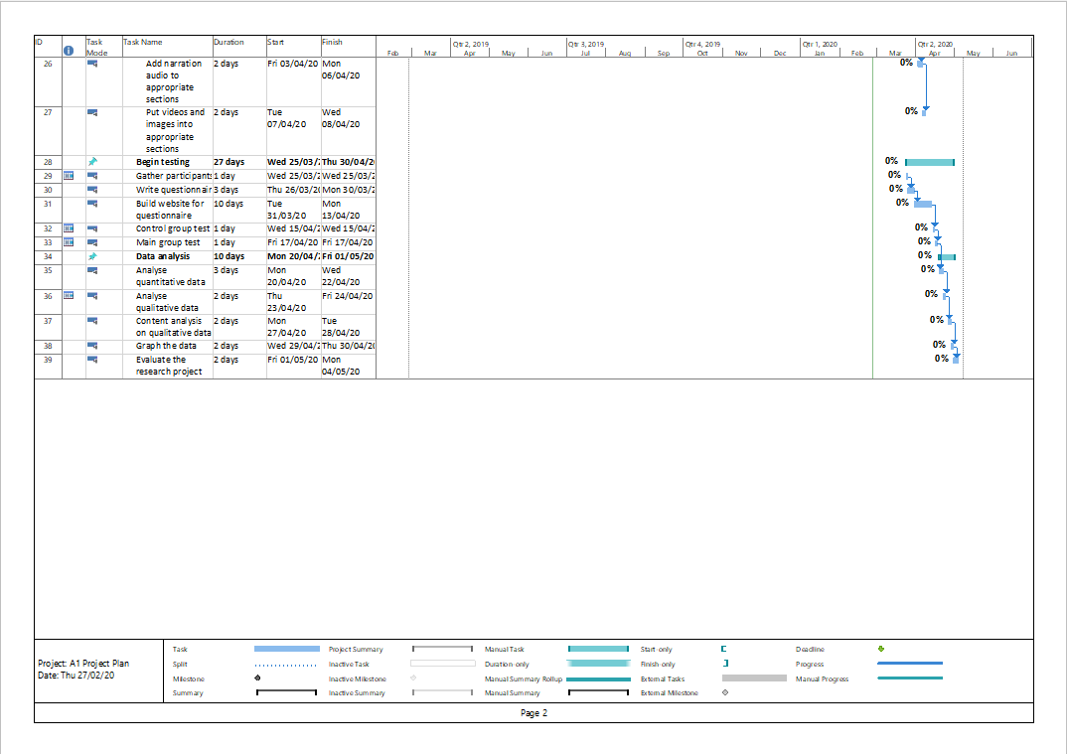

## Schedule

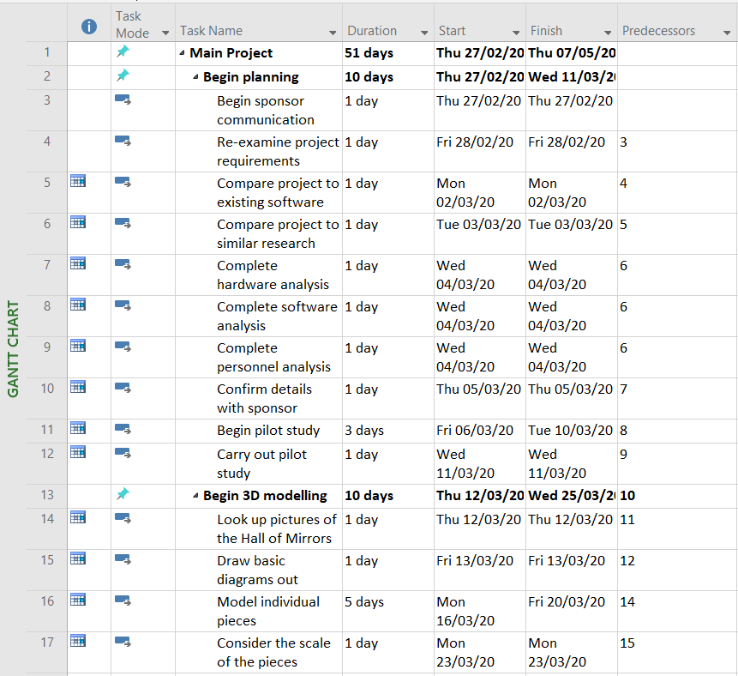

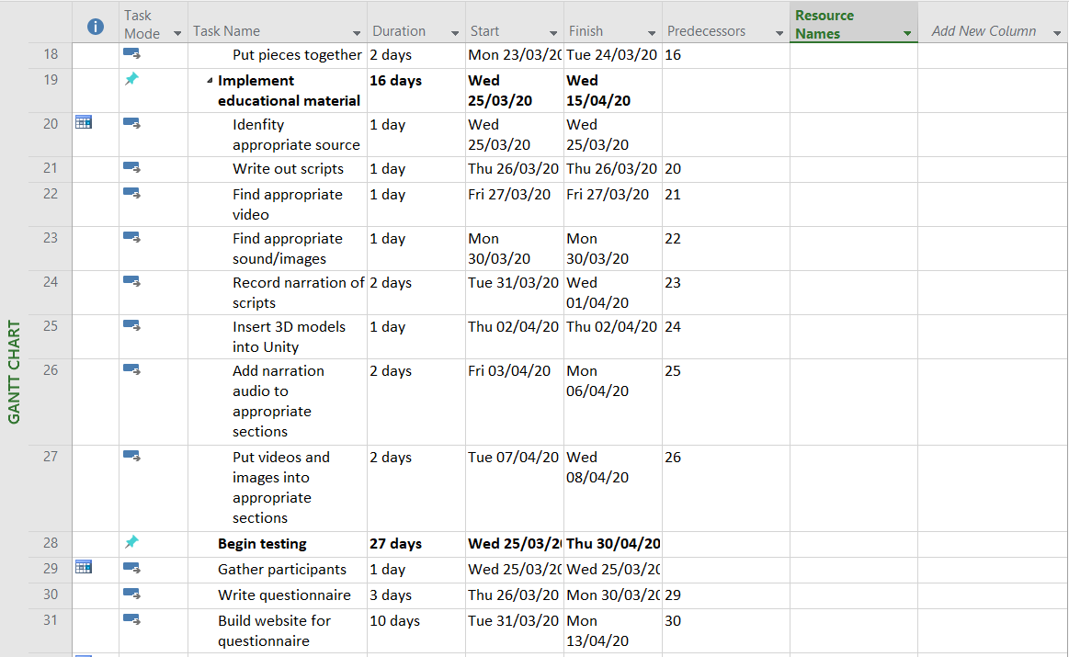

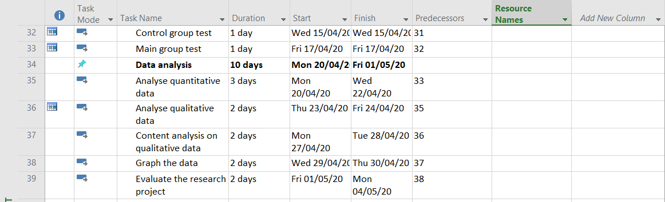

## Gantt Chart

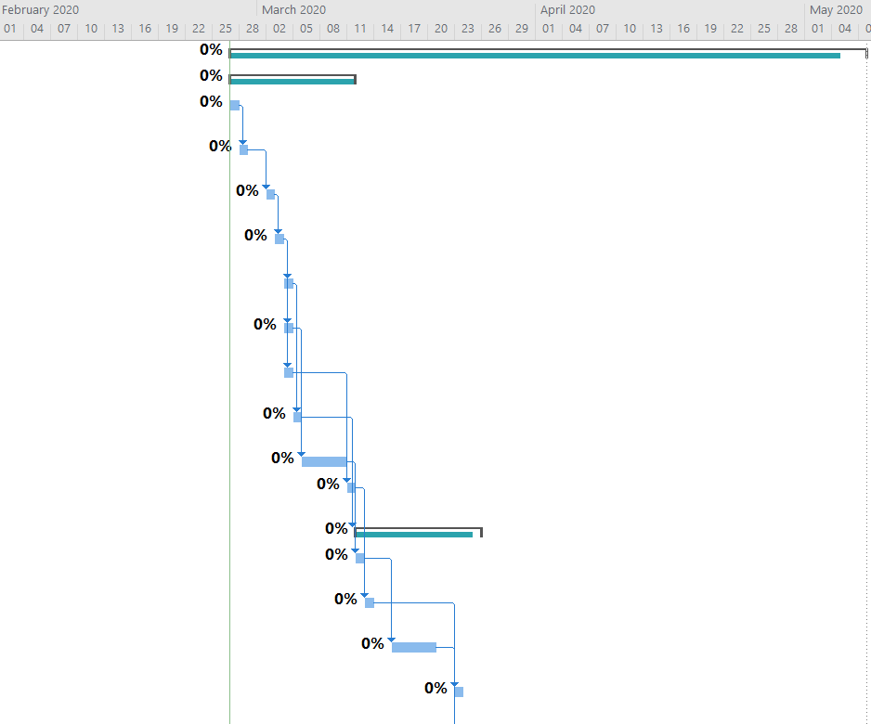

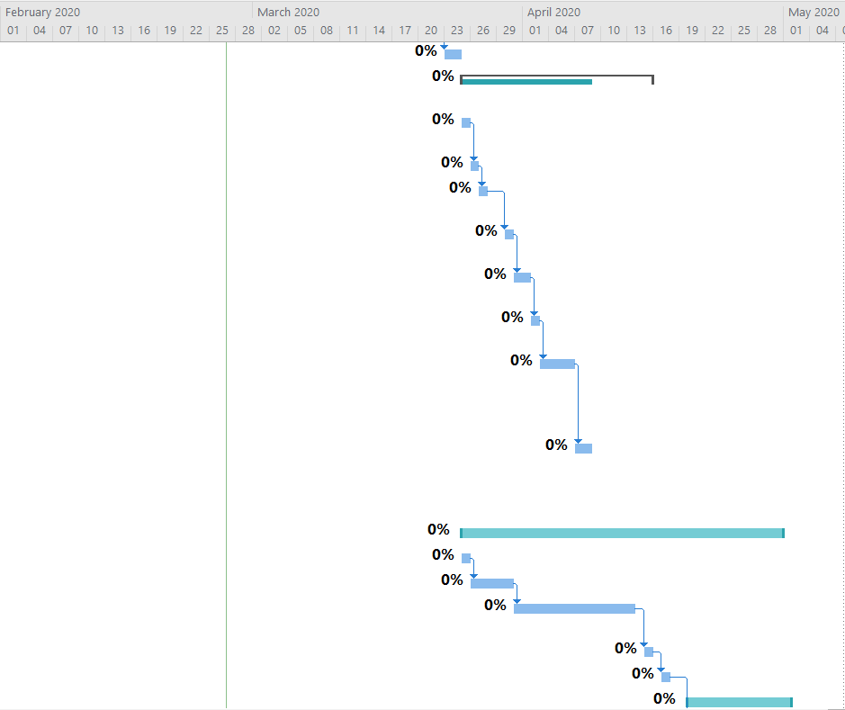

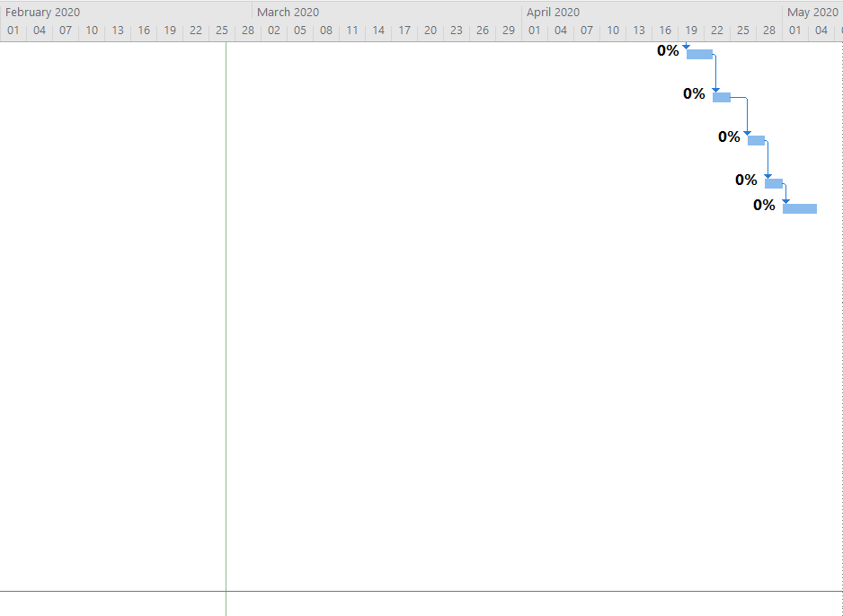

# References

Adobe, 2020. *Buy Adobe Premiere Pro.* [Online]   
Available at: https://www.adobe.com/uk/products/premiere.html  
[Accessed 24 February 2020].

AQR, 2020. *Definition: Professional Standards.* [Online]   
Available at: https://www.aqr.org.uk/glossary/professional-standards  
[Accessed 26 Feburary 2020].

Autodesk, 2020. *3DS Max.* [Online]   
Available at: https://www.autodesk.com/products/3ds-max/overview  
[Accessed 24 February 2020].

Black, E. R., 2017. *LEARNING THEN AND THERE: AN EXPLORATION OF VIRTUAL REALITY IN K-12 HISTORY EDUCATION.* [Online]   
Available at: https://repositories.lib.utexas.edu/bitstream/handle/2152/63616/Black_Thesis_Exploration.of.VR.in.K12.education_2017.pdf?sequence=2  
[Accessed 14 November 2019].

Burke, S. C. & Snyder, S. L., 2008. YouTube: An Innovative Learning Resource for College Health Education Courses. *International Electronic Journal of Health Education,* Volume 11, pp. 39-46.

Denscombe, M., 2002. *Ground Rules for Social Research: Guidelines for Good Practice.* [Online]   
Available at: https://books.google.co.uk/books/about/Ground_Rules_for_Social_Research.html?id=9QBFBgAAQBAJ&printsec=frontcover&source=kp_read_button&redir_esc=y#v=onepage&q&f=false  
[Accessed 6 January 2020].

Eggarxou, D., 2007. Teaching history using a Virtual Reality Modelling Language model of Erechtheum. *International Journal of Education and Development using Information and Communication Technology*, pp. 115-121.

GOV.UK, 2020. *Data protection.* [Online]   
Available at: https://www.gov.uk/data-protection  
[Accessed 24 February 2020].

Jaffar, A. A., 2012. YouTube: An emerging tool in anatomy education. *Anatomical Sciences Education,* 5(3), pp. 125-186.

JetBrains, 2020. *Webstorm: The smartest JavaScript IDE.* [Online]   
Available at: https://www.jetbrains.com/webstorm/  
[Accessed 24 February 2020].

Kuo, E. W. & Lévis, M., 2002. *A New Roman World: Using Virtual Reality Technology as a Critical Teaching Tool,* New Orleans: ERIC.

Lighthouse3D, 2020. *View Frustum Culling.* [Online]   
Available at: http://www.lighthouse3d.com/tutorials/view-frustum-culling/  
[Accessed 26 February 2020].

Microsoft, 2020. *What's new in Office 365.* [Online]   
Available at: https://support.office.com/en-GB/article/What-s-new-in-Office-365-95c8d81d-08ba-42c1-914f-bca4603e1426  
[Accessed 24 February 2020].

Neamtu, C. et al., 2012. *Using virtual reality to teach history.* [Online]   
Available at: https://s3.amazonaws.com/academia.edu.documents/54335777/110541496-Proceedings-of-ICVL-2012-ISSN-1844-8933-ISI-Proceedings.pdf?response-content-disposition=inline%3B%20filename%3DEnhancing_English_Language_Writing_and_S.pdf&X-Amz-Algorithm=AWS4-HMAC-SHA25  
[Accessed 14 November 2019].

Palace of Versailles, 2020. *History.* [Online]   
Available at: http://en.chateauversailles.fr/discover/history#today  
[Accessed 7 January 2020].

Pithon, M. M., 2013. Importance of the control group in scientific research. *Dental Press Journal of Orthodontics,* 18(6).

Pletinckx, D., Callebaut, D., Killebrew, A. & Silberman, N., 2000. Virtual-reality heritage presentation at Ename. *IEEE MultiMedia,* 7(2), pp. 45-48.

Skillshare, 2019. *Online Classes by Skillshare.* [Online]   
Available at: https://www.skillshare.com/  
[Accessed 9 December 2019].

Tutorialspoint, 2020. *Project Management Triangle.* [Online]   
Available at: https://www.tutorialspoint.com/management_concepts/project_management_triangle.htm  
[Accessed 27 February 2020].

Unity, 2020. *Create and Monetize Games with Unity Gaming Solutions.* [Online]   
Available at: https://unity.com/solutions/game  
[Accessed 24 Februrary 2020].

Yildrim, G., Elban, M. & Yildrim, S., 2018. Analysis of Use of Virtual Reality Technologies in History Education: A Case Study. *Asian Journal of Education and Training,* 4(2), pp. 62-28.

# Bibliography

Alison, J., 2007. *History educators and the challenge of immersive pasts: a critical review of virtual reality ‘tools’ and history pedagogy.* [Online]   
Available at: https://www.tandfonline.com/doi/abs/10.1080/17439880802497099  
[Accessed 11 December 2019].

BBC, 2017. *Virtual reality history lessons.* [Online]   
Available at: https://www.bbc.co.uk/news/av/education-39388424/virtual-reality-history-lessons  
[Accessed 11 December 2019].

Camic, P. M. (. R. J. E. (. Y. L. (., 2003. Qualitative research in psychology: Expanding perspectives in methodology and design.. s.l.:PsycINFO Database Record.

ClassVR, 2019. *School VR Subjects: Historical Times Lessons.* [Online]   
Available at: https://www.classvr.com/school-curriculum-content-subjects/historical-times-lessons/  
[Accessed 11 December 2019].

Hedberg, J. & Alexander, S., 1994. Virtual Reality in Education: Defining Researchable Issues. *Educational Media International,* 31(4), pp. 214-220.

Helsel, S., 1992. Virtual Reality and Education. *Educational Technology,* 32(5), pp. 38-42.

Hills, P., 2008. Authentic learning and multimedia in history education. *Learning, Media & Technology,* 33(2), pp. 87-99.

Isadore Newman, C. R. B. C. S. R., 1998. Qualitative-quantitative Research Methodology: Exploring the Interactive Continuum. s.l.: Southern Illinois University Press .

Ken Peffers, T. T. A. R. &. C., 2014. A Design Science Research Methodology for Information Systems Research. Journal of Management and Information Systems, 24(3), pp. 45-77.

Kirsch, G. & Sullivan, P. A., 1992. Methods and Methodology in Composition Research. s.l.:Southern Illinois University Pr.

Kothari, C. R., 2004. Research Methodology: Methods and Techniques. s.l.:New Age International.

Laura Freina, M. O., 2015. *A Literature Review on Immersive Virtual Reality in Education: State Of The Art and Perspectives.,* Genova: s.n.

Mackenzie, N. & Knipe, S., 2008. Research dilemmas: Paradigms, methods and methodology. Issues In Educational Research, Volume 16, pp. 1-11.

Marczyk, G. D. D. &. F. D., 2005. Essentials of behavioral science series. Essentials of research design and methodology. s.l.:John Wiley & Sons Inc.

Masterman, E. & Rogers, Y., 2002. A framework for designing interactive multimedia to scaffold young children's understanding of historical chronology. *Instructional Science,* Volume 30, pp. 221-241.

Mayer, R. E. & Moreno, R., 2011. *A Cognitive Theory of Multimedia Learning: Implications for Design Principles,* Santa Barbara: University of California.

Pantelidis, V. S., 2009. Reasons to Use Virtual Reality in Education and Training Courses and a Model to Determine When to Use Virtual Reality. *Themes in Science and Technology Education,* 2(2), pp. 59-70.

Paz, P. H.-R. &. S. D. L., 2009. Learning History in Middle School by Designing Multimedia in a Project-Based Learning Experience. *Journal of Research in Technology and Education,* 42(2), pp. 151-173.

Psotka, J., 1995. Immersive training systems: Virtual reality and education and training. *Instructional Science,* Volume 23, pp. 405-431.

Weimer, W. B., 2013. Notes On The Methodology Of Scientific Research. [Online] Available at: <https://pdfs.semanticscholar.org/ae86/42578e978747be357a1b11452ccb75008228.pdf> [Accessed 7 January 2020].

# Appendices

## A – Additional information for Paper 1 (Neamtu, et al., 2012)

Noting that 3D models with sufficient detail provide experiences close to real life, the study employs a method that is intended to developer VR in learning and teaching history. It notes that educational VR applications are focused around highly accurate virtual artifact models produced with engineering techniques. By using laser scanners with built-in texturing, artifacts can be digitalised, reconstructed and optimised until an accurate artifact is designed. With these scanners, 3D models and virtual copies were able to be produced that preserved the artifacts’ accuracy, as well as accepting guidance from archaeologists. Environments were also scanned in certain scenarios to simulate where the artifact was found. This allowed for accurate illustration of a Dacian forge found in present-day Romania. These higher-resolution illustrations better illustrated to users the appearance and use of these artifacts than standard 3D modelling. The study recommends using their methodology for historical teaching applications.

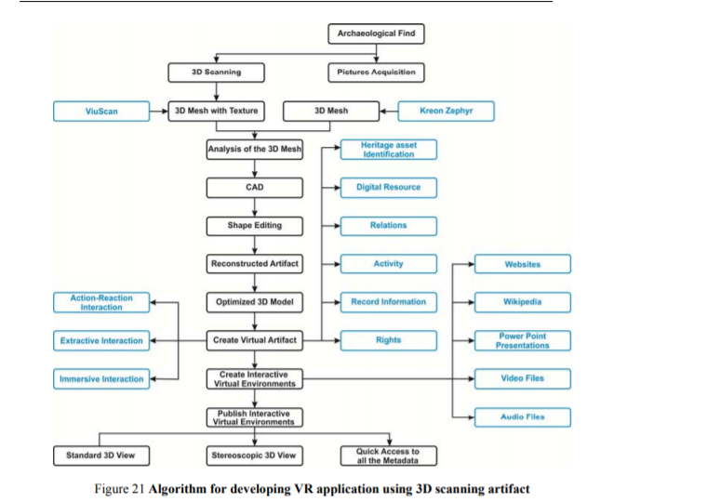

Figure 1: Algorithm for developing VR applications

The paper’s findings successfully illustrate that multimedia applications, and especially newer applications that have developed considerably in the past decade such as VR, have brought dynamic changes to education. They illustrate that new, highly accurate ways of 3D modelling is feasible enough for researchers to not be present at historical sites. They support the idea that education has been changed by multimedia considerably and can be further supported by studies such as the one discussed in Paper 2.

## B – Additional information for Paper 2 (Eggarxou, 2007)

Through the use of the Cortona Client Software Program, using drawings of the Erechtheum and appropriate scaling techniques, the paper’s team used computer-aided design (CAD) to install and place objects together (e.g building columns) and add appropriate textures especially developed for the project, while making minor assumptions and simplifications. Designed for primary school learning, it teaches students through the use of a Virtual Reality Modelling Language (VRML), employing design principles aimed at creating a visually appealing, immersive and educational experience for children. To ensure accuracy, the buildings parts were split up and analysed as separate floors, walls, columns and the ground. The roof was also similarly spilt up. A sample of Year 5 students were then given use of the program, while a control group were given textbooks and images of the Erechtheum and taught conventionally.

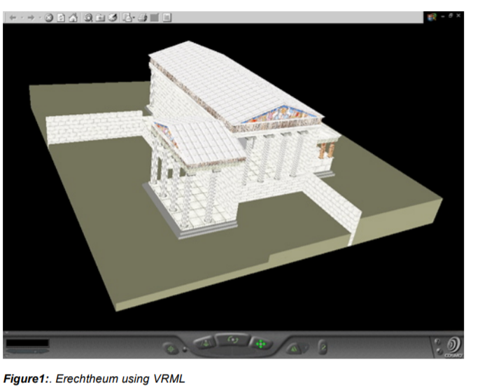

Figure 2: model of Erechtheum in VRML

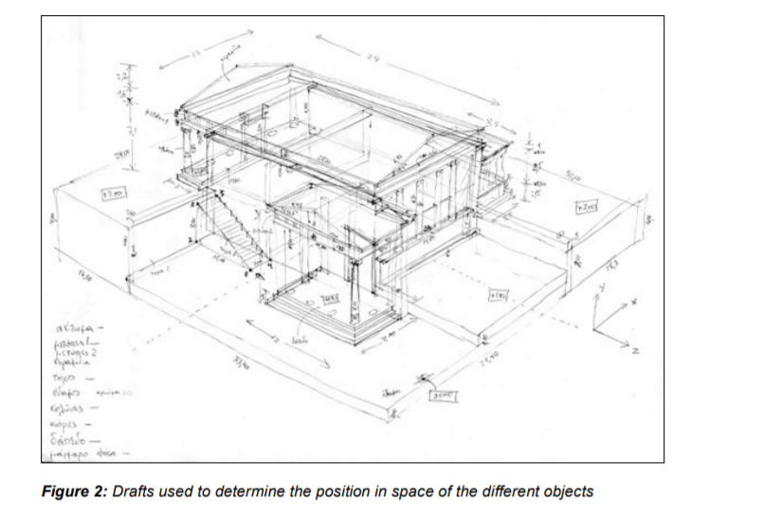

Figure 3: drafts to determine dimensions of objects

This paper illustrates that VR in education can be more effective than traditional means with textbook illustrations, providing users a dynamic, immersive experience that allows them to better learn through technology that remains not as commonplace as traditional systems. Like Paper 1, the influence of physical models have considerably aided in student comprehension.

## C – Additional information for Paper 3 (Kuo & Lévis, 2002)

Students were presented with reconstructed models of significant sites such as the Roman Colosseum and given controls to navigate through. 37000 students were sampled and placed in a large room with an encompassing spherical screen. The screen displayed 3D models that students were able to interact with in real time. Afterwards, students and educators alike were quizzed and answered questions

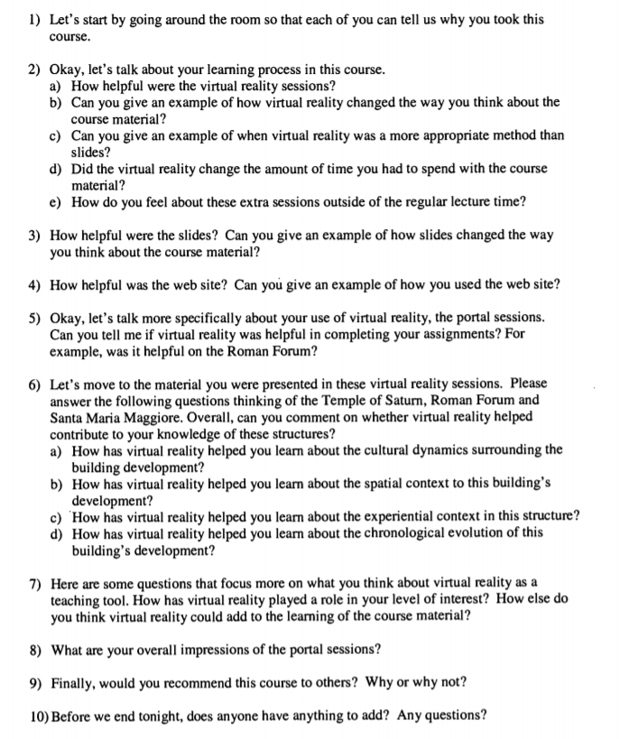

Figure 4: Student survey

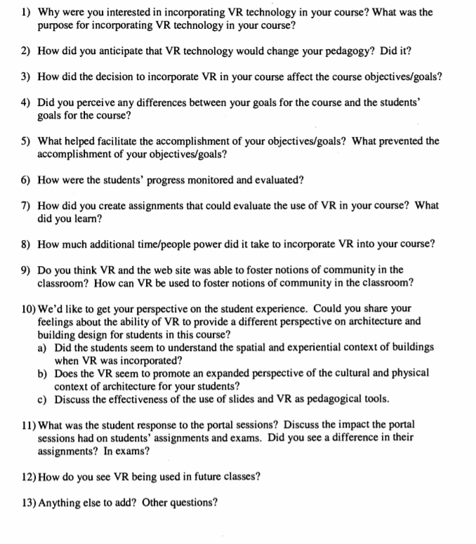

Figure 5: educator survey

Like Paper 1 and 2, Paper 3 illustrates improved student comprehension, though this study also considers that educators learn themselves from engaging in a new teaching technique. The study illustrates how multimedia and VR have considerably developed the fields of education in recent years.

## D – Additional information for Paper 4 (Black, 2017)

Paper 4 examines current popular VR applications, how VR is utilised currently within classrooms, as well as whether or not it is utilised effectively, giving examples of companies employing it for educational purposes effectively, such as Google **Invalid source specified.**. It also examines specific simulations such as the *Apollo 11* moon landing and the wreckage of the *Titanic.* Next, Paper 4 examines VR’s impact on histiography – how history is documented and recorded – which can be compared to Paper 3’s illustration of history’s subjectivity in that by putting the user within the setting of the historic environment, they experience it for themselves, and not from a textbook or lecturer. Finally, it focuses on effectively implementing educational VR and ethical implications when teaching history in VR, such as simulating inappropriate or traumatic events in history such as the Holocaust, and whether or not VR is better used outside of such events.

## E – Additional information for Paper 5 (Yildrim, et al., 2018)

This case study focuses purely on undergraduate students mostly unfamiliar with VR. They were firstly given a 5-minute VR activity to familiarise themselves with VR interaction. From there, a simulation of the Kaaba was presented to students, with included audio and visual elements. Participants were able to learn and interact at their own pace. Afterwards, participants were then asked in interviews on their general opinion about VR in order to indirectly assess their opinion on VR headsets in history education.

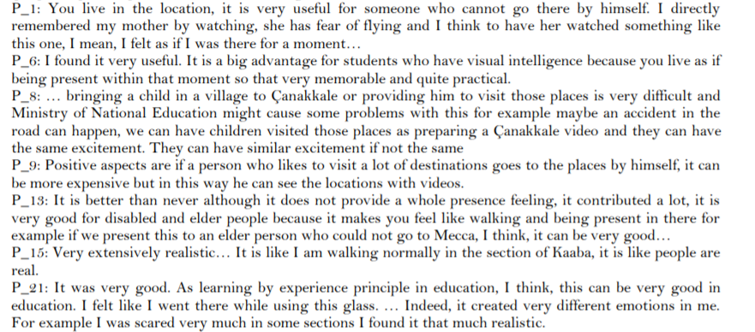

Figure 6: Answers for the question “What are the Opinions of Participants toward Use of VR Glasses?”

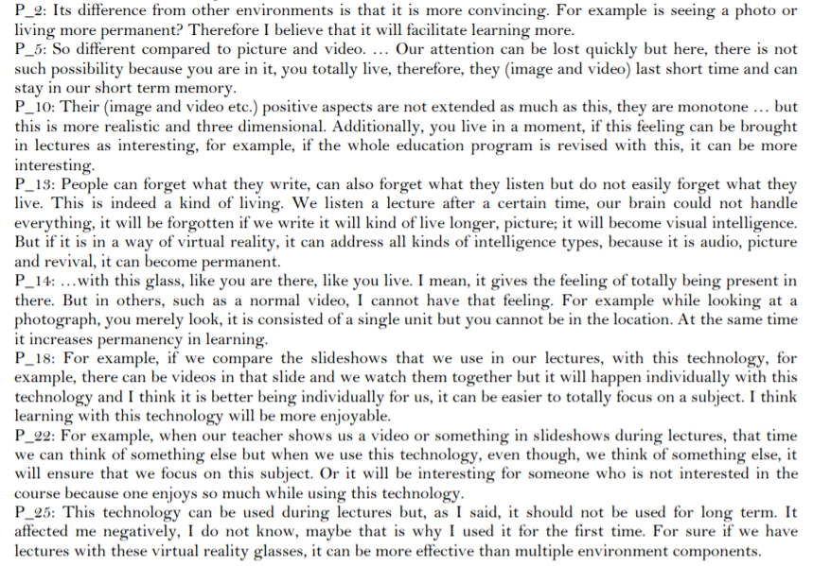

Figure 7: Answers for the question “What are the Opinions of Participants toward the Differences of Use of Multiple Environment Contents Provided with VR Glasses and Use of the Materials, I.E. Video and Images, Provided in Traditional Learning Processes?”

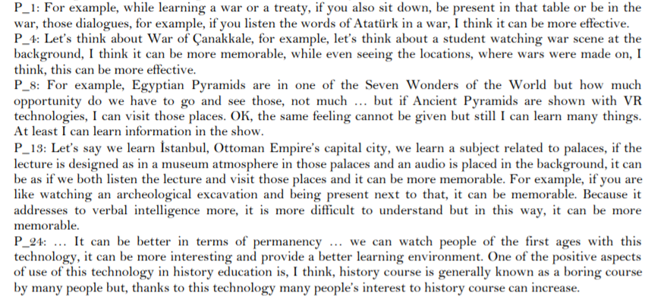

Figure 8: Answers for the question “What are the Opinions of Participants toward Use of VR Glasses in History Education?

## F – Additional information for Paper 6 (Pletinckx, et al., 2000)

The project required recreating remains of the old town and displaying them to the general public through VR, as specific structures are unrecognisable from their original form. Ethical issues were avoided by the team as rather than reconstructing the town, using an on-site VR set to see Ename as it was in the Medieval period, while leaving the remains of the town untouched. Within the museum itself, a large amount of interactive multimedia is featured, with VR featuring most prominently, including an interactive 3D reconstruction of how the area has changed over a millennium, which the user is able to explore. By cross-referencing historical documents and archaeological research, each era and how the town changed over the centuries can be accurately displayed and interacted with.

While important to note this study is older than other significant papers referenced, this paper acts as a good example of early VR implementation, with solid methodology that can be examined closely at later stages of research conducted by the author.

## G – Norman and Schneiderman’s HCI principles (Shneiderman, 1997), (Norman, 1990)

Human-computer interaction (HCI) examines computing systems and whether they’ve been designed and implemented effectively for human use.

To ensure this, Don Norman proposed 7 design principles:

|  |  |
| --- | --- |
| 1 | Use both knowledge in the world and knowledge in the head. |
| 2 | Simplify the structure of tasks. |
| 3 | Make things visible. |
| 4 | Get the mappings right. |
| 5 | Exploit the power of constraints, both natural and artificial. |
| 6 | Design for error. |
| 7 | When all else fails, standardize­ |

(Norman, 1990)

Ben Shneiderman also wrote 8 “golden rules” for designing an interface.

|  |  |
| --- | --- |
| 1 | Strive for consistency |
| 2 | Enable frequent users to use shortcuts |
| 3 | Offer informative feedback |
| 4 | Design dialogs to yield closure |
| 5 | Offer error prevention and simple error handling |
| 6 | Permit easy reversal of actions |
| 7 | Support internal locus of control |
| 8 | Reduce short-term memory load |

(Shneiderman, 1997)

Both Norman’s and Schneiderman’s rules will be taken into consideration when the implementation phase begins. Thanks to following these principles, ensuring user interaction with the final product is more satisfactory than otherwise will be considerably simpler. Besides these, other aspects useful to consider are learnability, flexibility and robustness (Webb, 2019).

## H – User Centered Design (Abras, 2004)

User Centred Design (UCD) regards any design process significantly influenced by the user. So long as it is influenced in some way, be it small or large, it can be considered user-centred. Due to the end user otherwise not usually being involved in the design process, it being designed from the user’s perspective has been a proposed reason as to why it is more understandable to the user (Kübler, 2014). Users’ influence in design has been shown to increase their overall satisfaction with their product.